There are a lot of facilities that can be found in the Labuan Financial Park and that includes

**-ATM MACHINE AND BANKS**

Maybank, CIMB, Bank Rakyat and Public Bank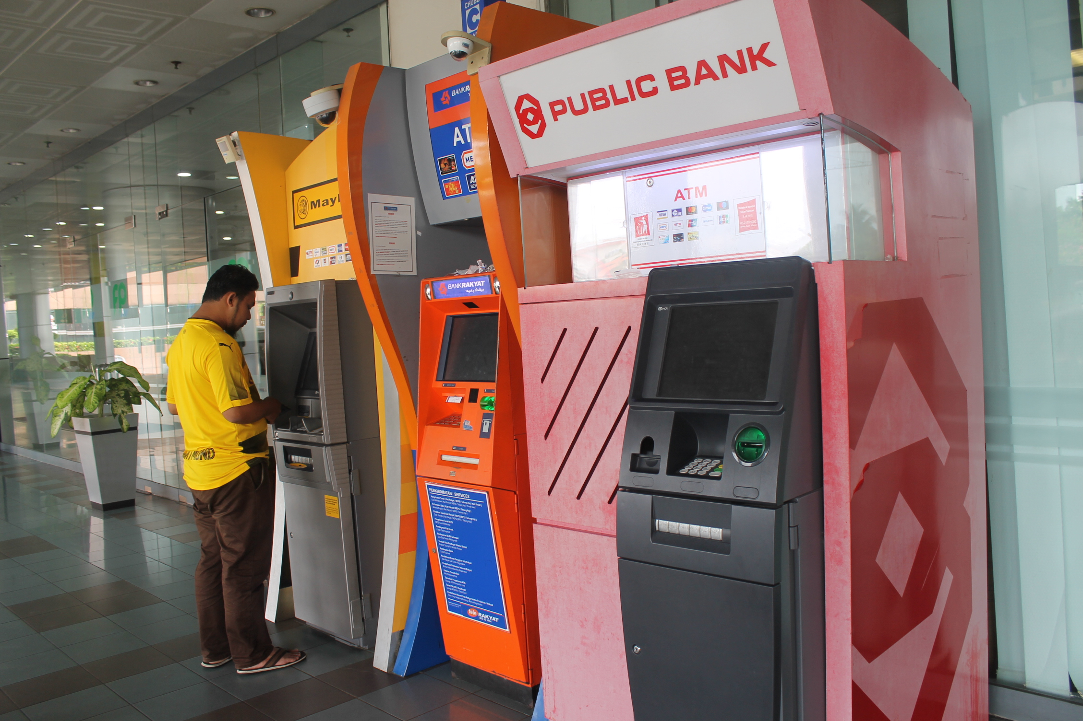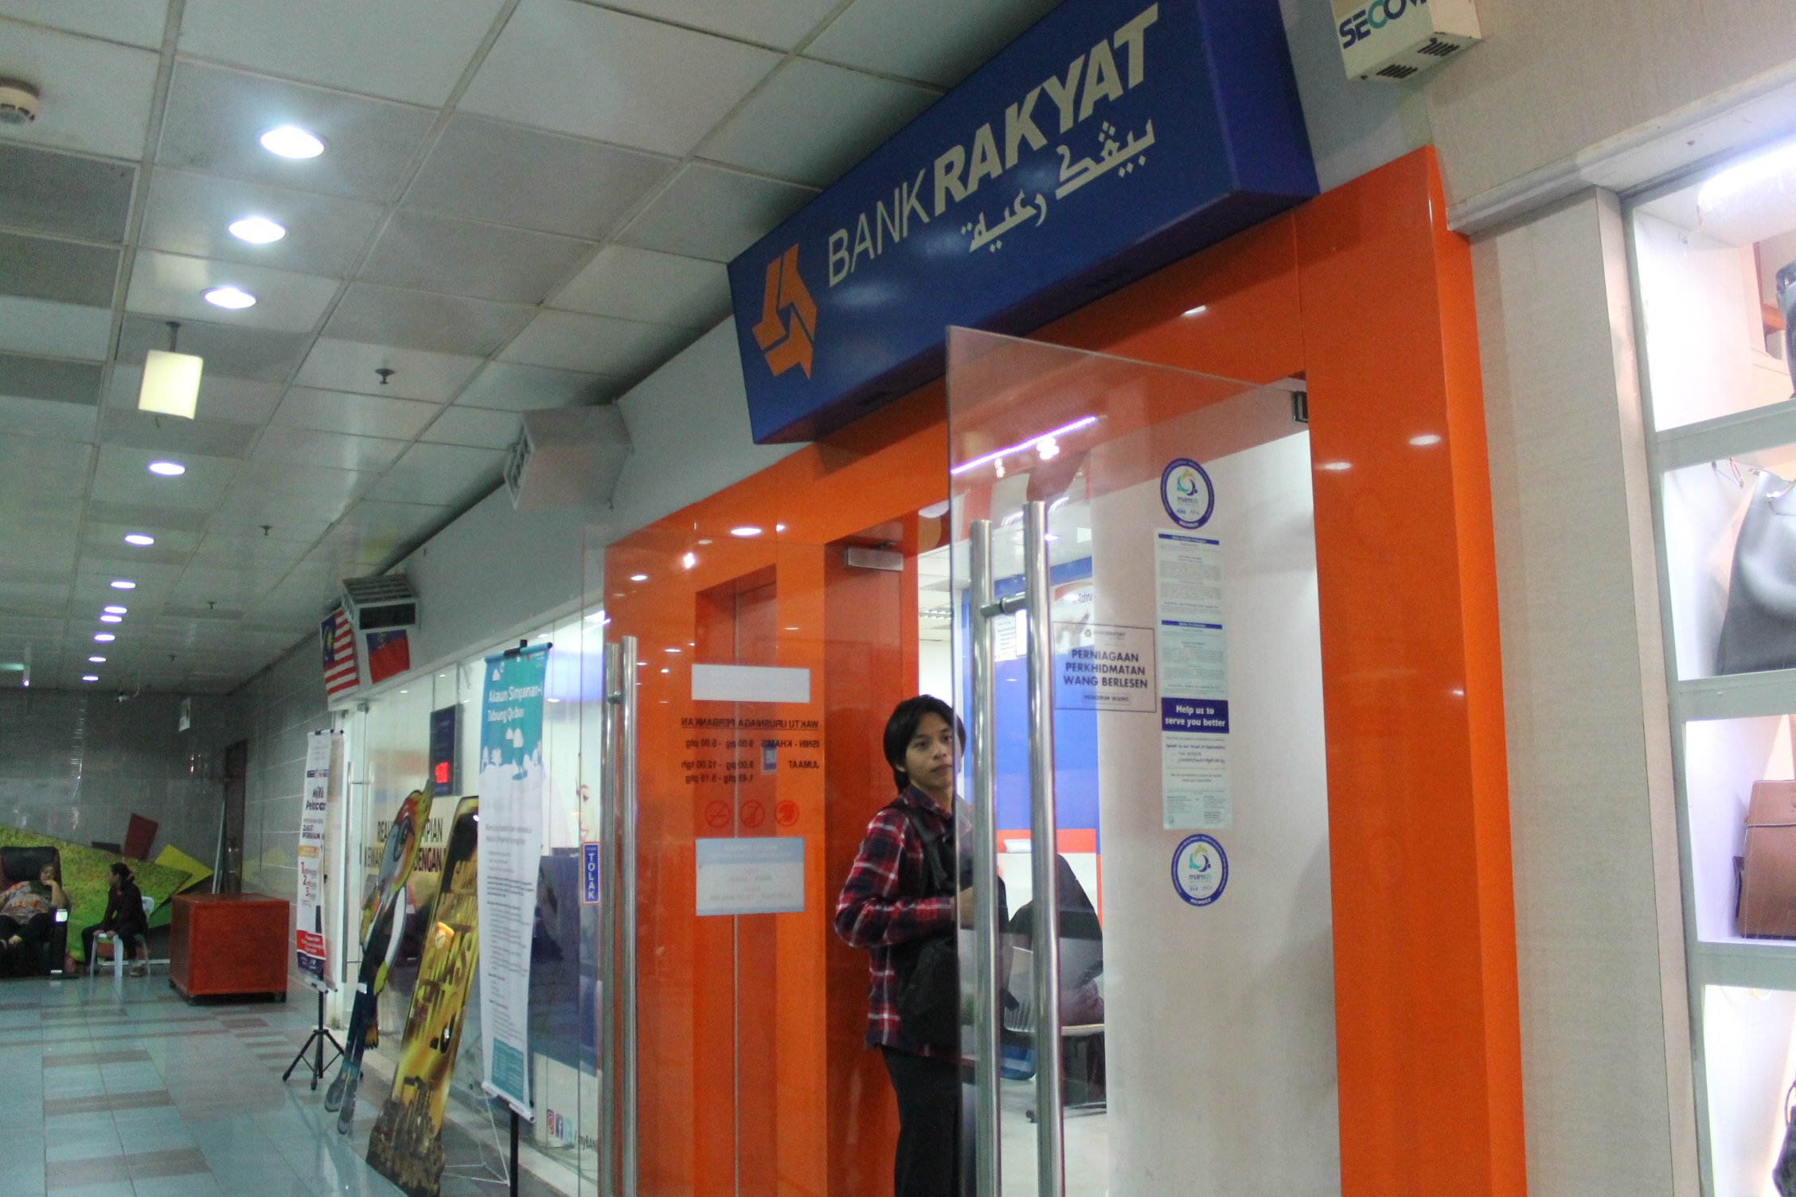

**-FOOD AND BEVERAGES**

That varies in Indian food, local Malaysian food to Western, Japanese, desserts and many more.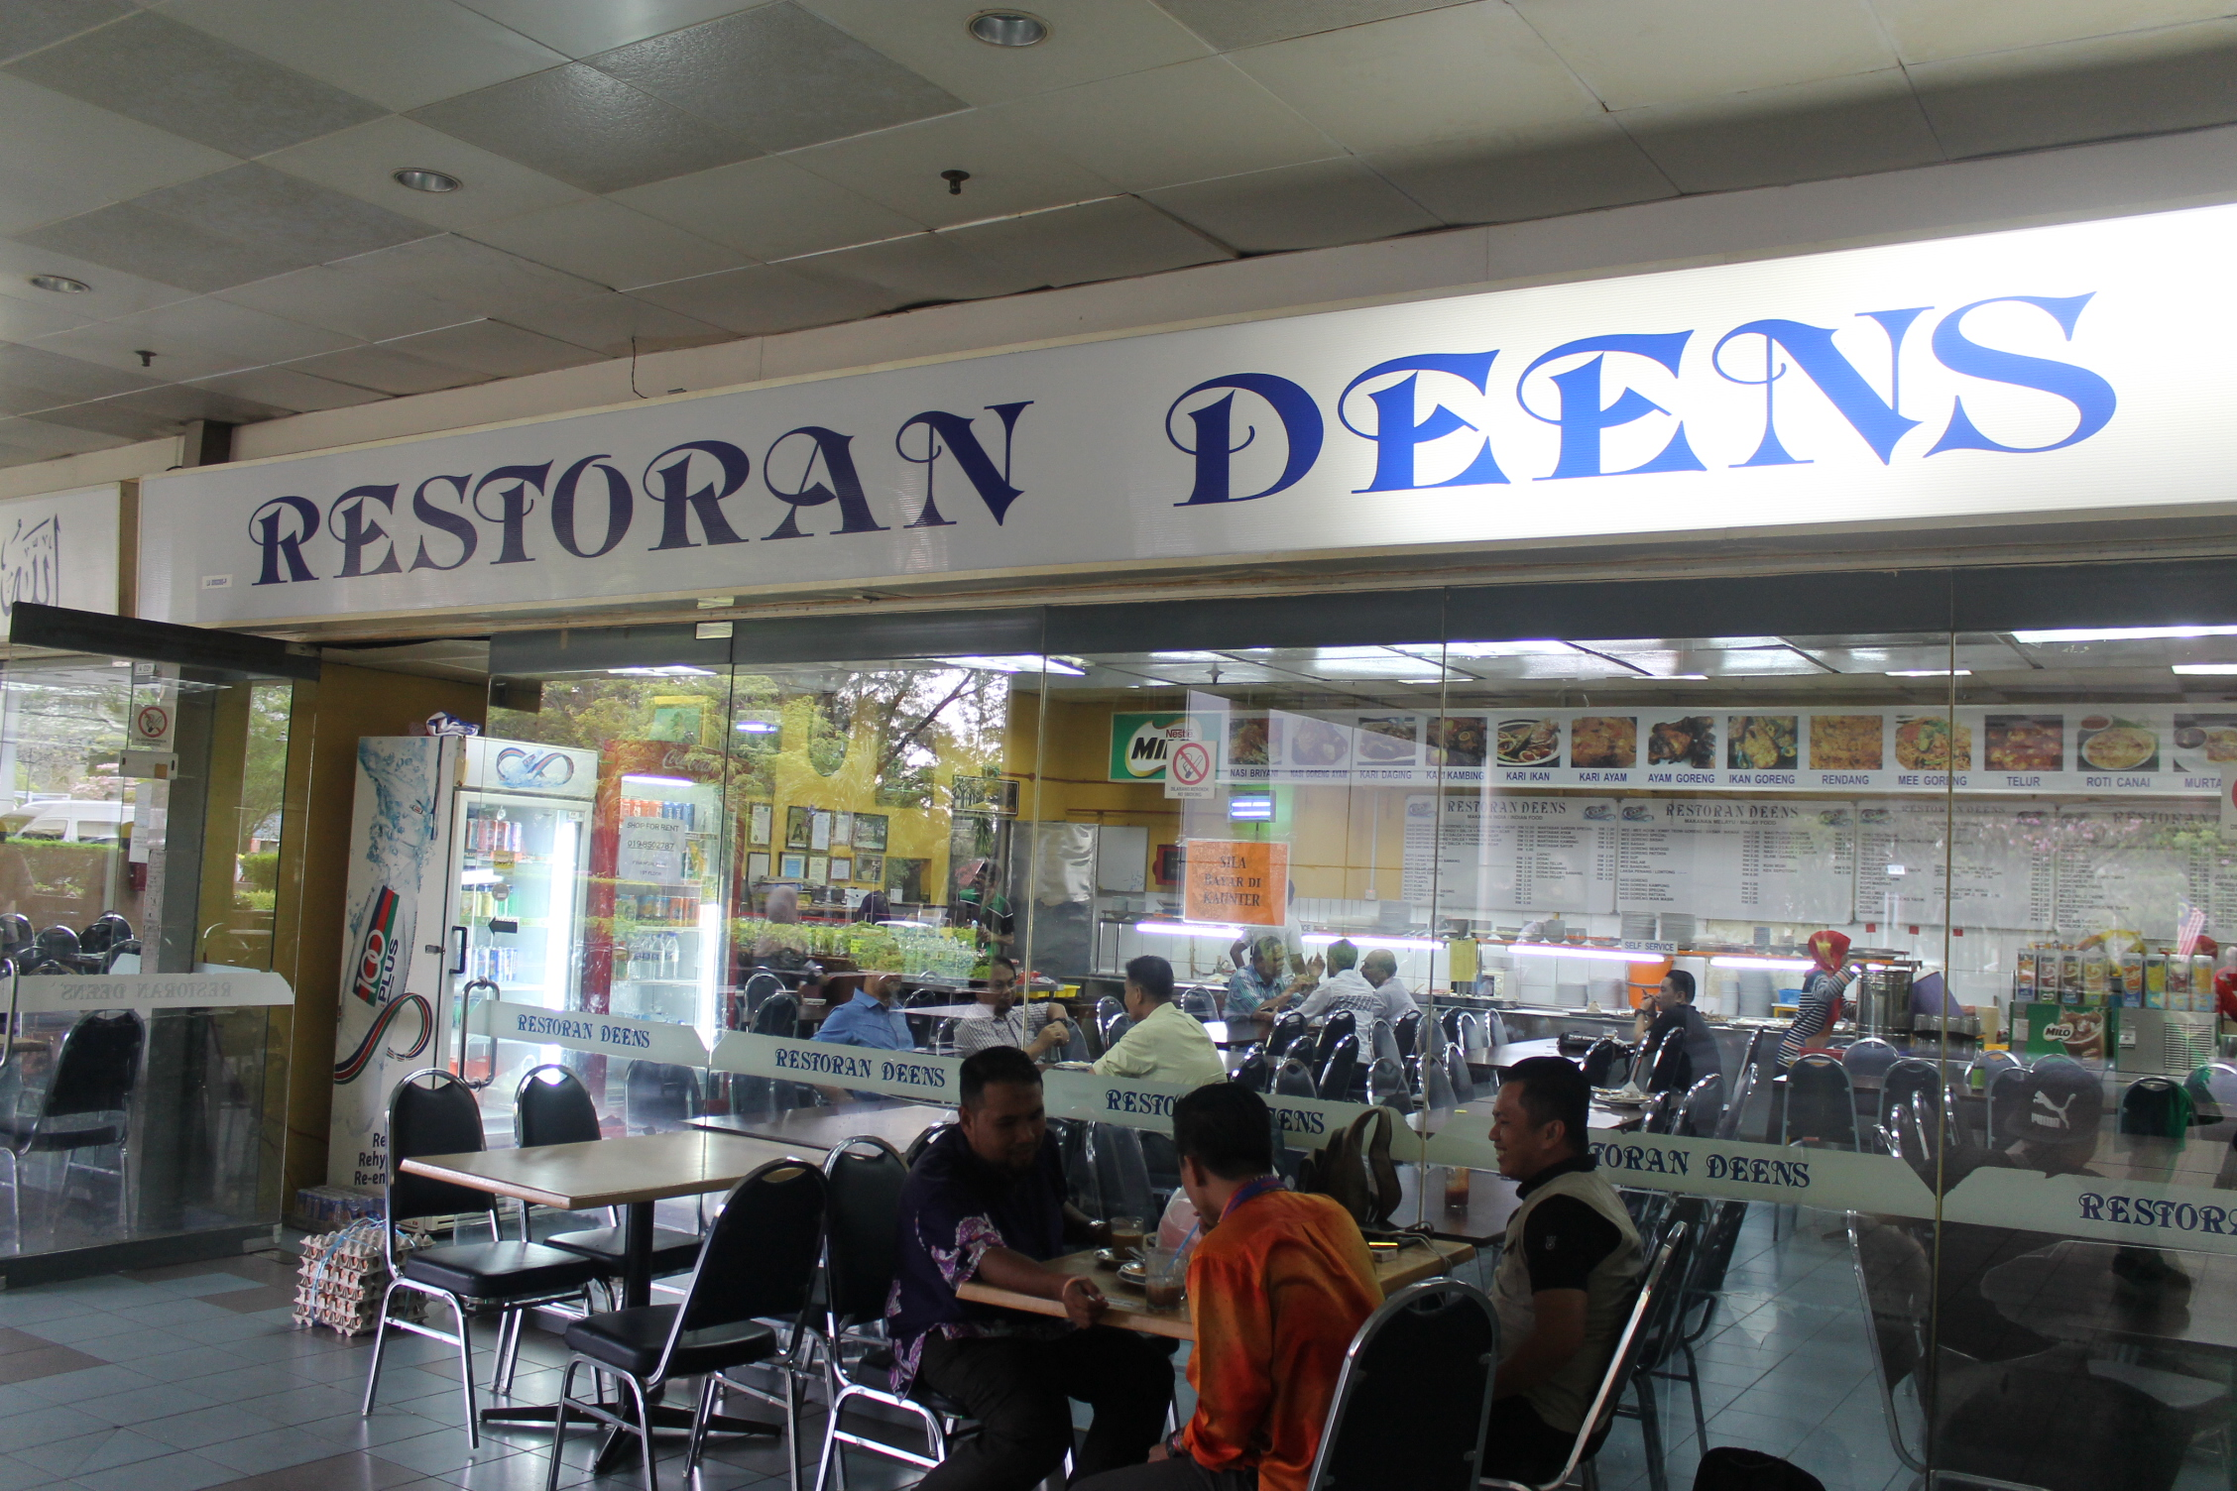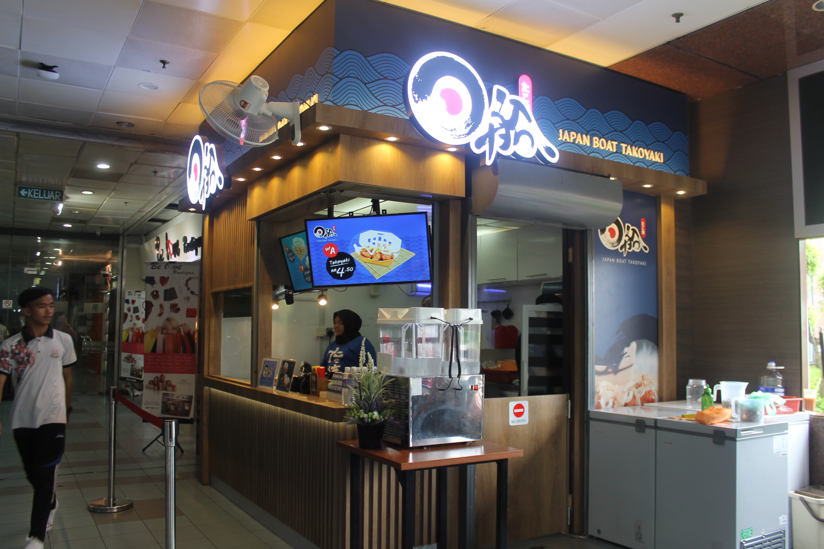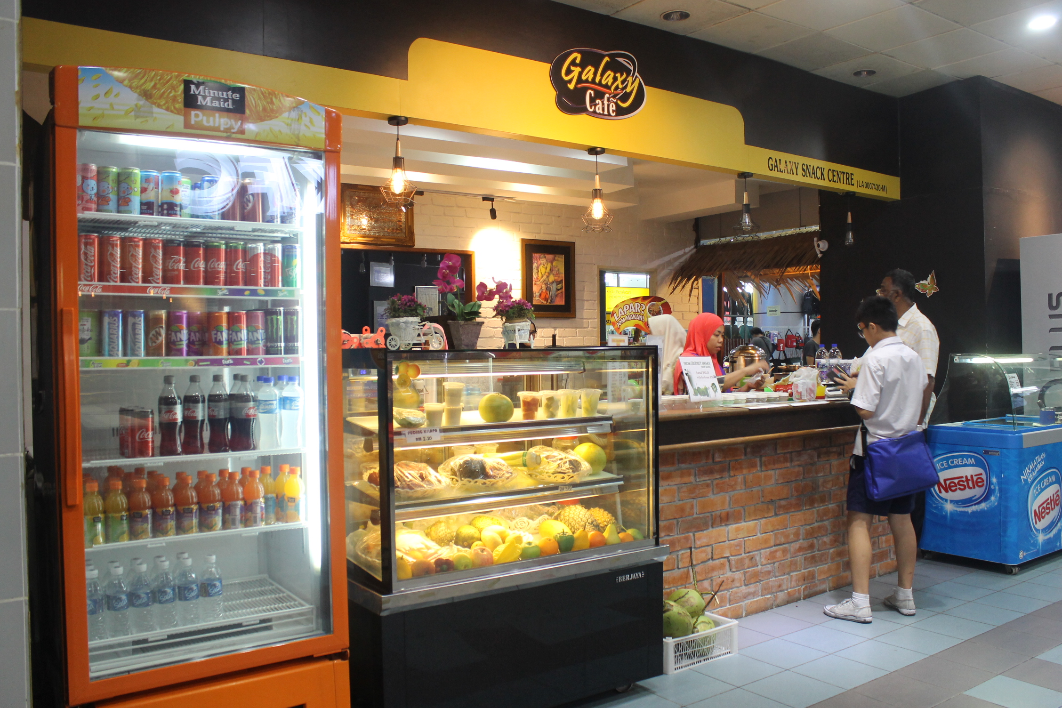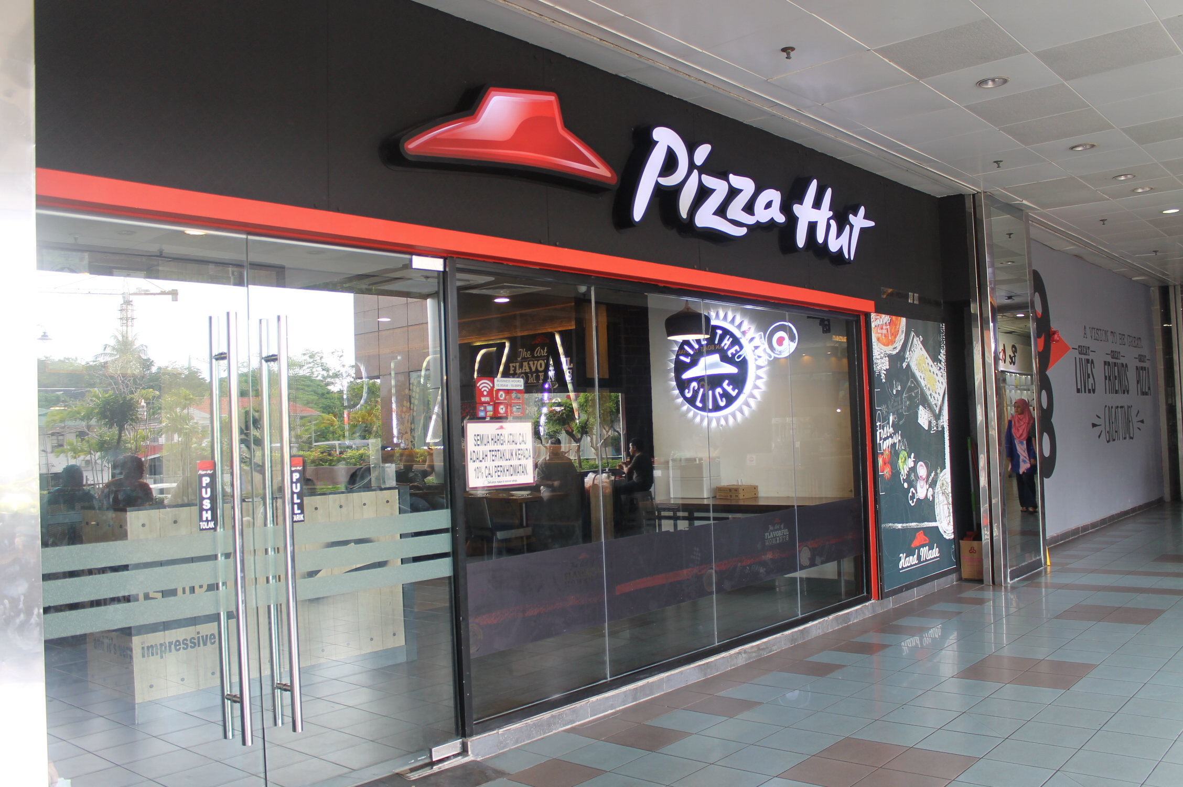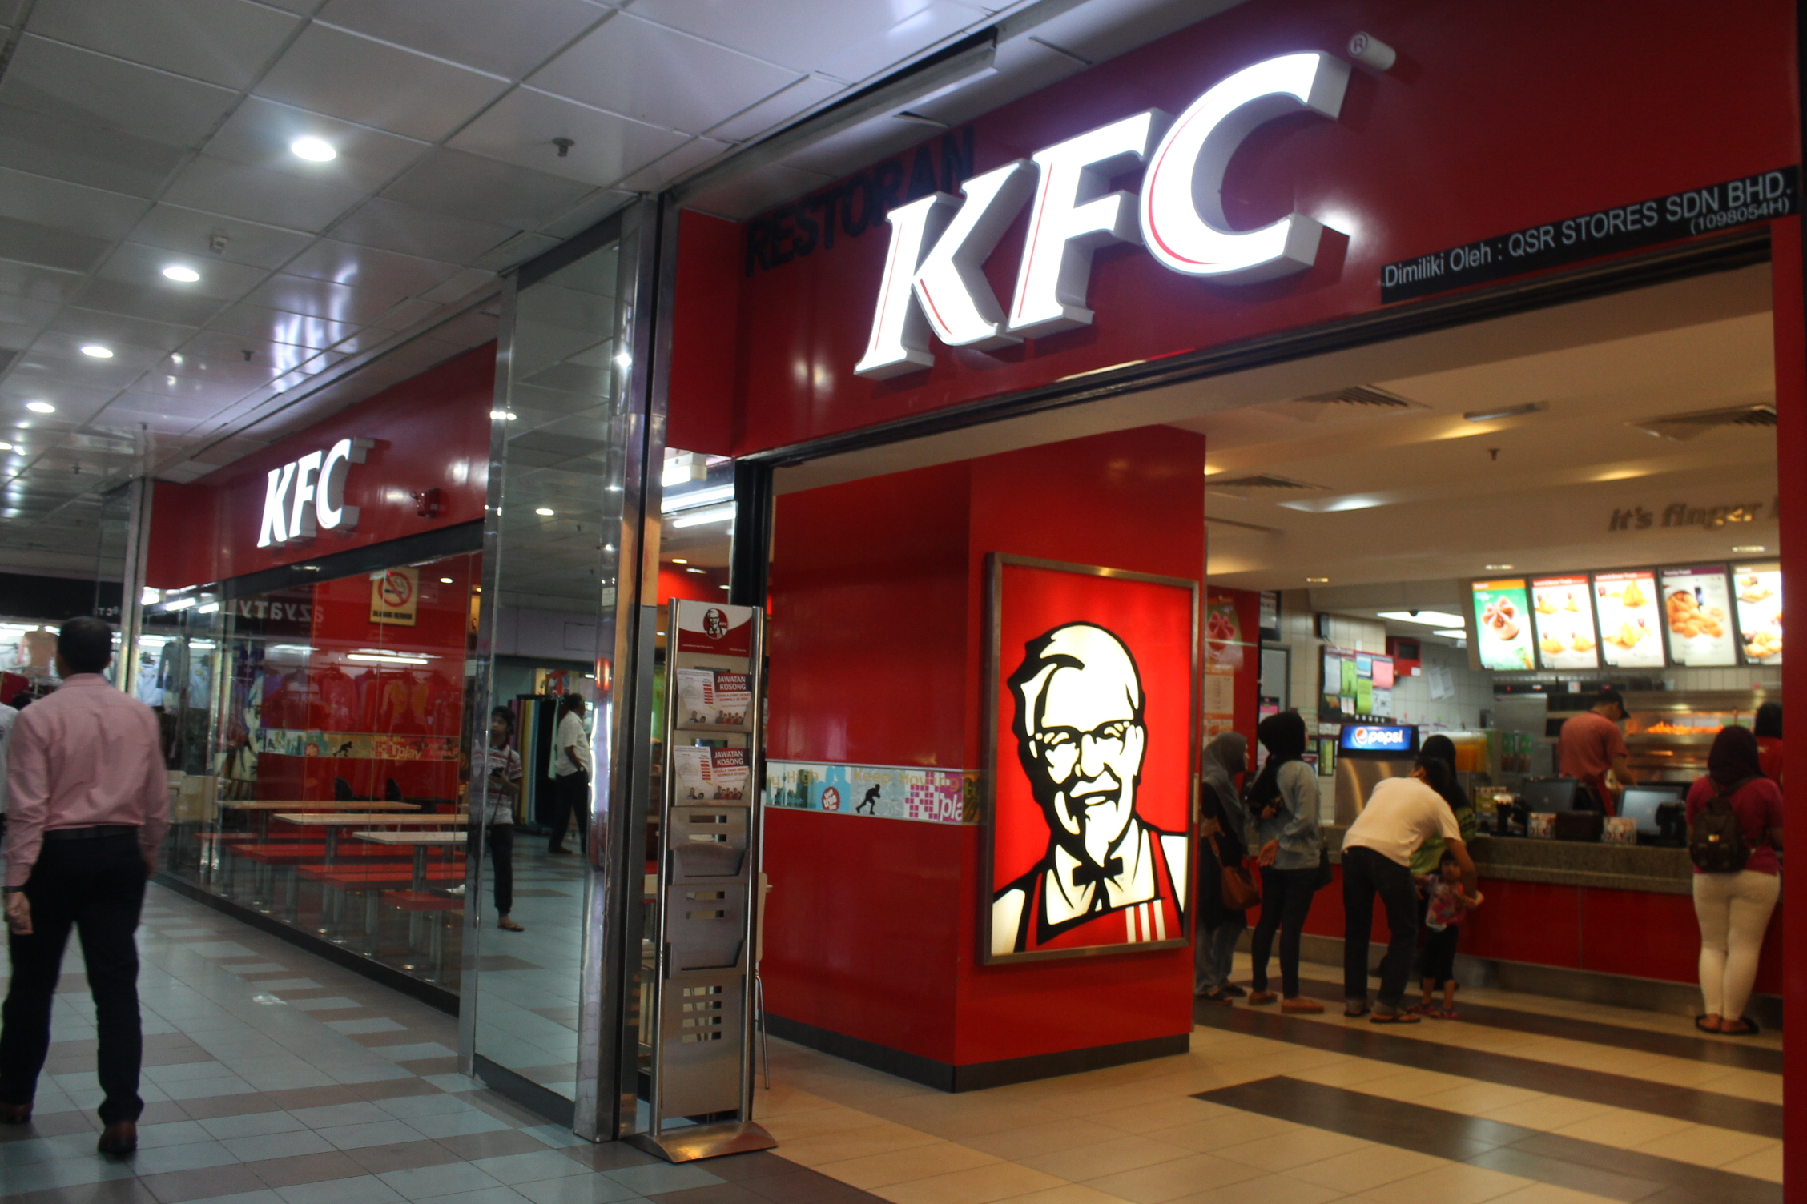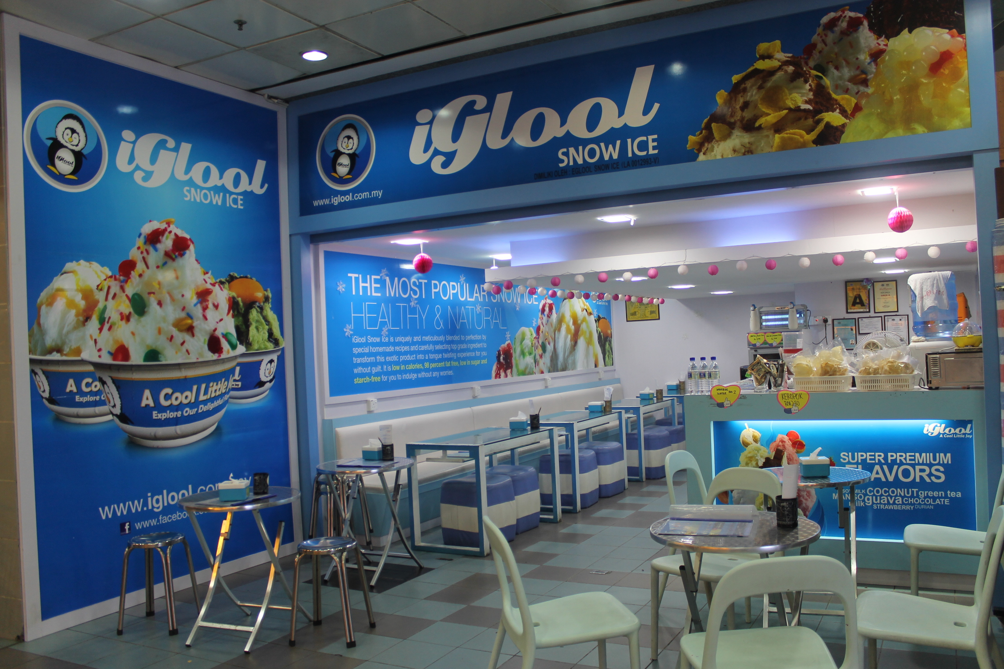

* Win Cafe
* Cool Blog
* Pizza Hut
* Japan Boat Takoyaki
* Uncle Bob
* Syam’s Restaurant
* KFC
* Galaxy Cafe
* Restoran & Bakeri Ikhwan
* Restoran Deens
* Iglool Snow Ice
* Food Court

**-CLOTHING**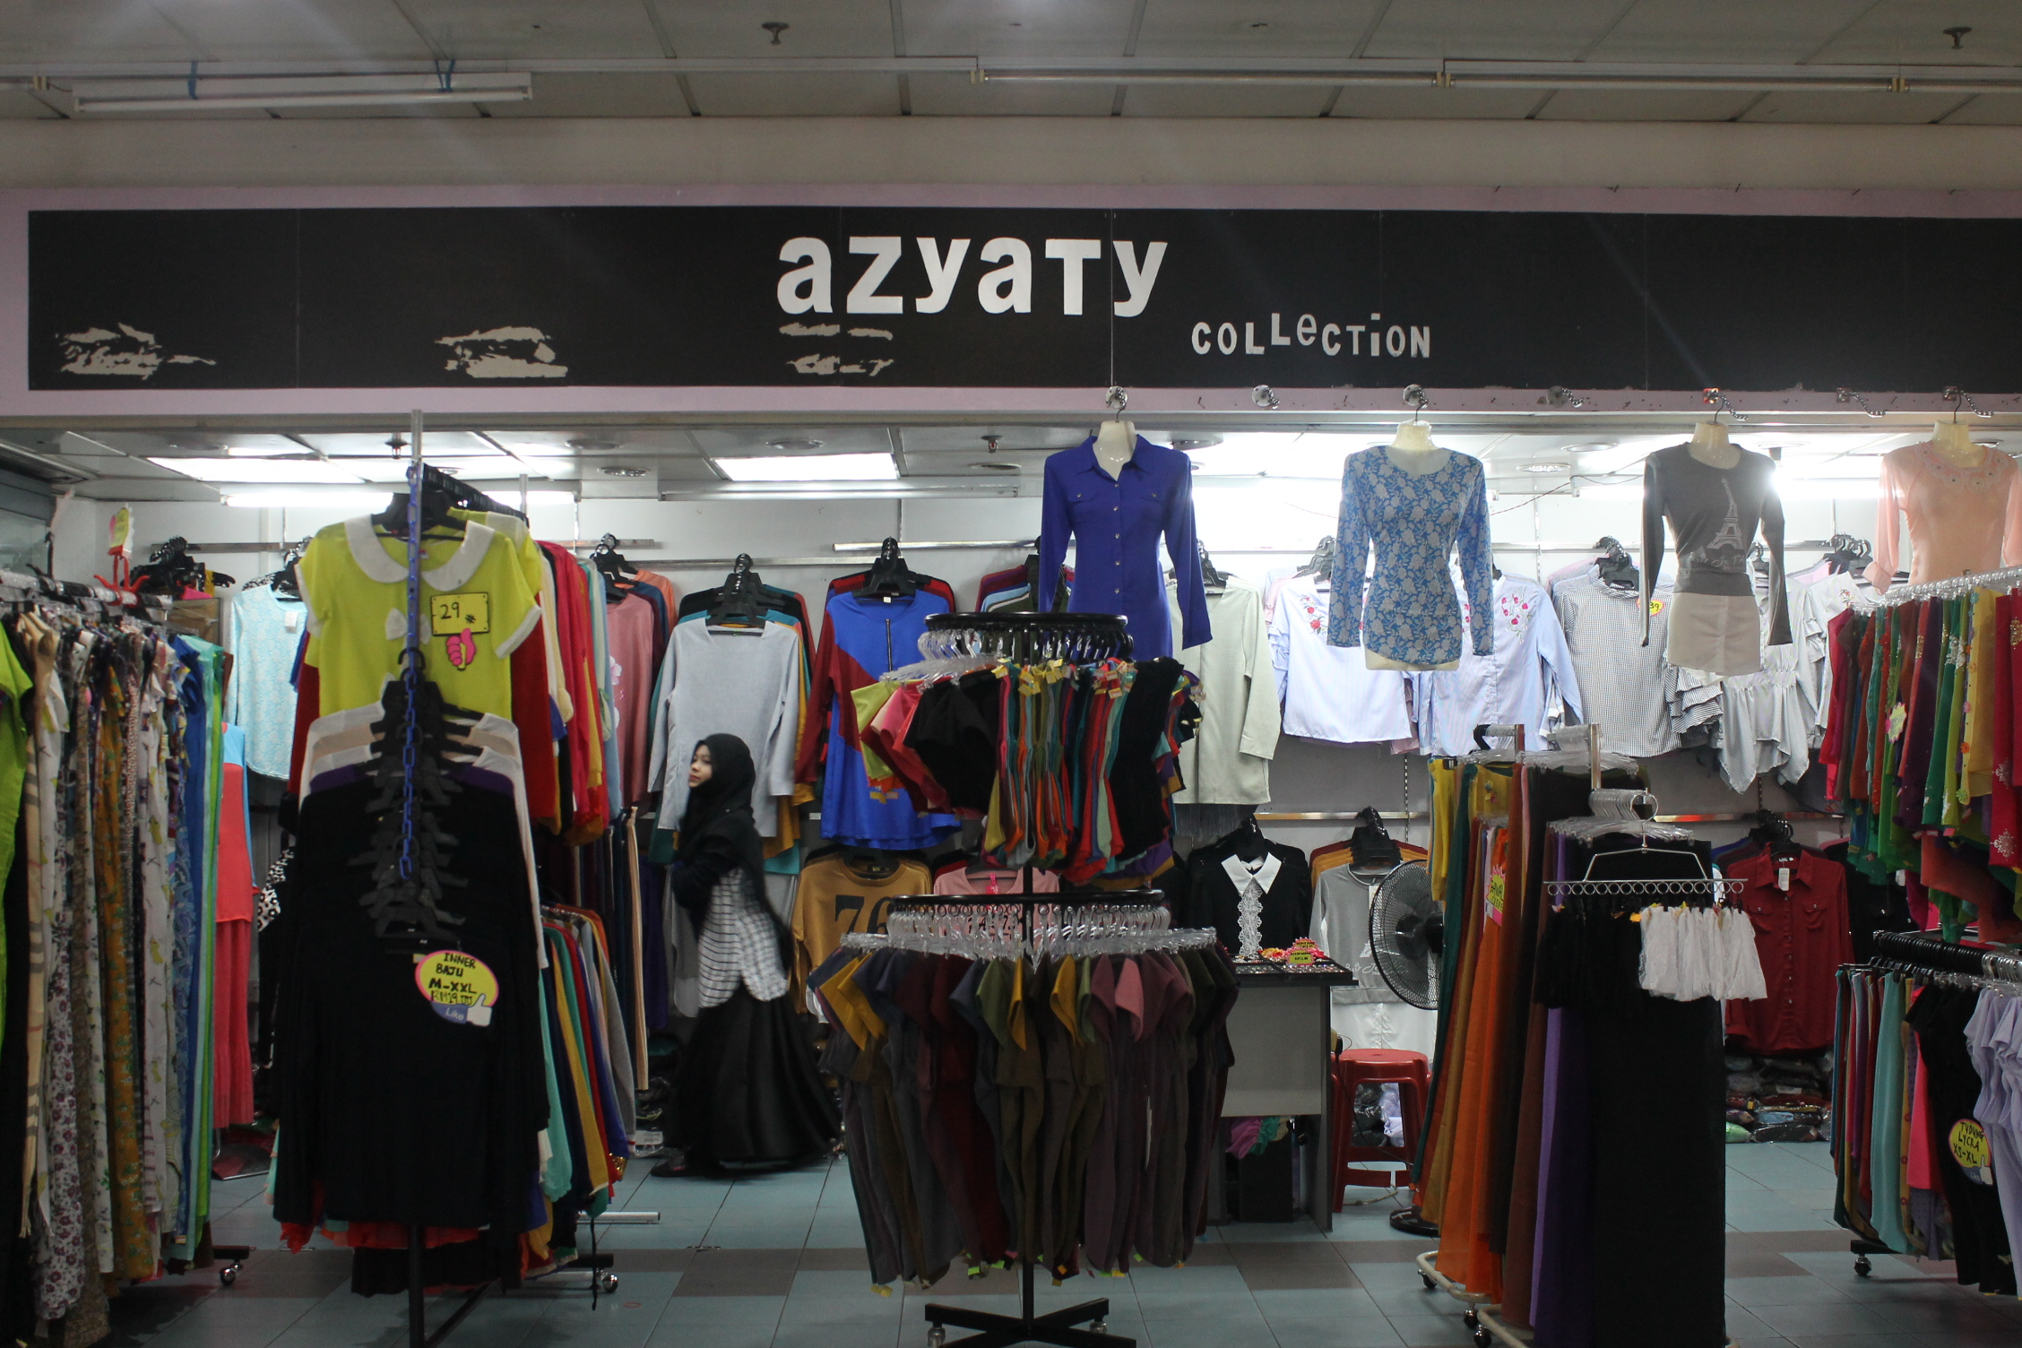

* Skechers
* LORREANA fashion store
* K.M SINGH
* Atta enterprise
* Chetak & Co
* Be Loved botique
* Busana Ratu
* Salam Silk’s Store
* azyaTy collection
* JIM’s Tailor
* The Palace Concept
* BOUJESS Fashion
* M&H smart store
* Maju&Harmoni snack food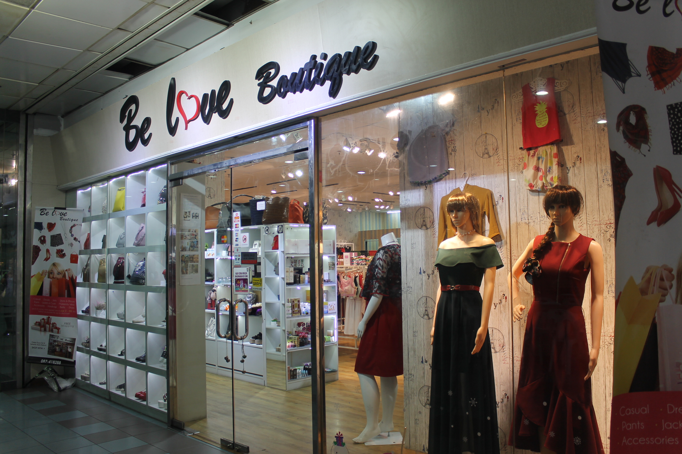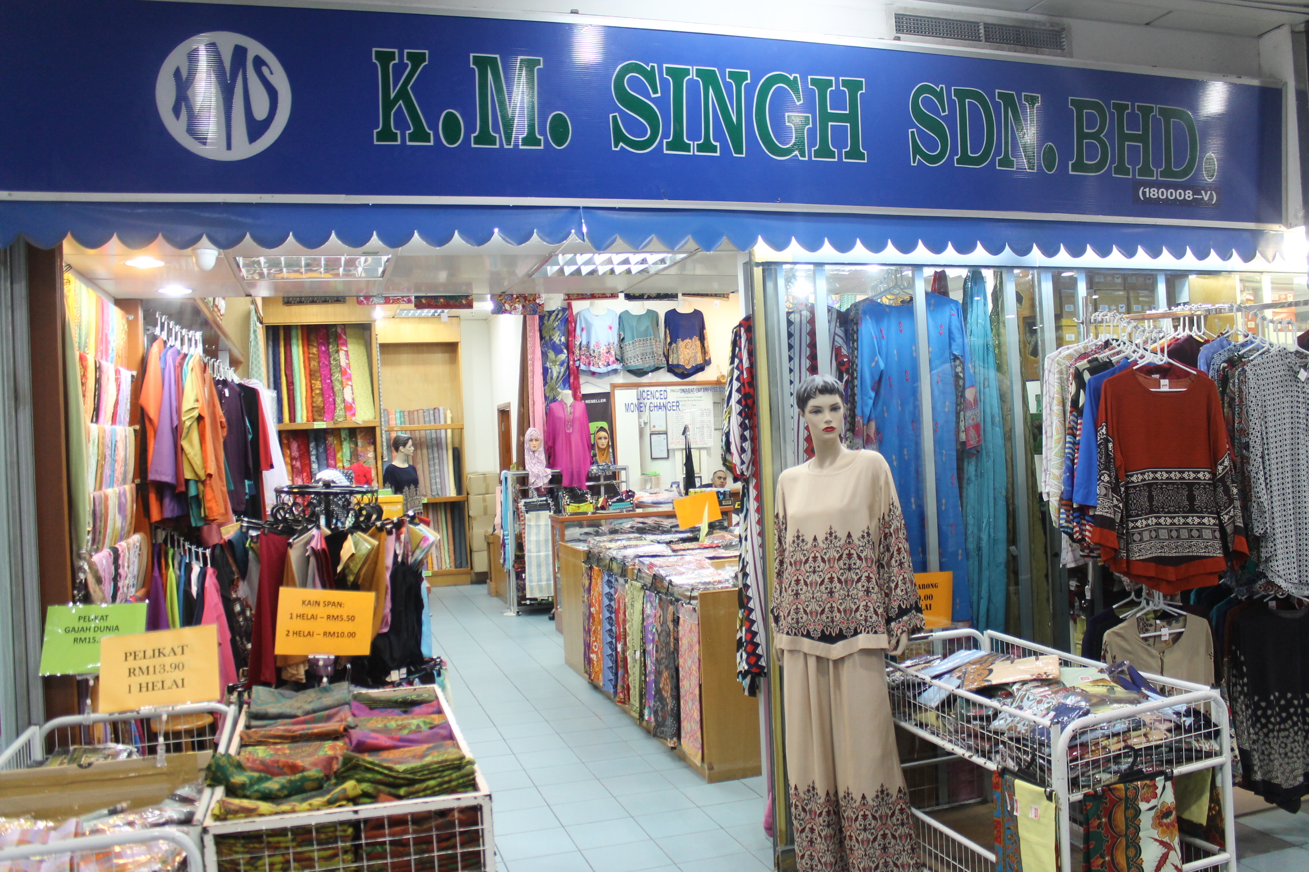

**-CONVINIENCE**

**Is where you find everything you need in your daily life.**

* Deen Genera Store
* SKC Import/Export trading
* MoneyGain
* Dayang stationary & supplies

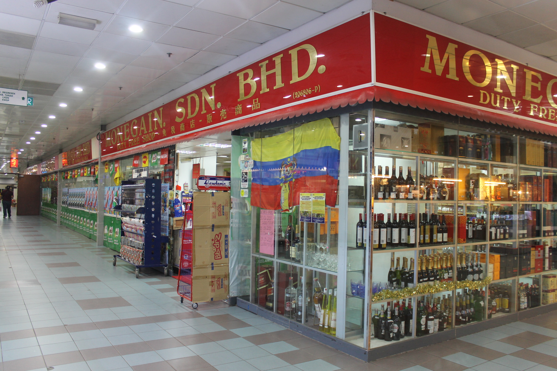

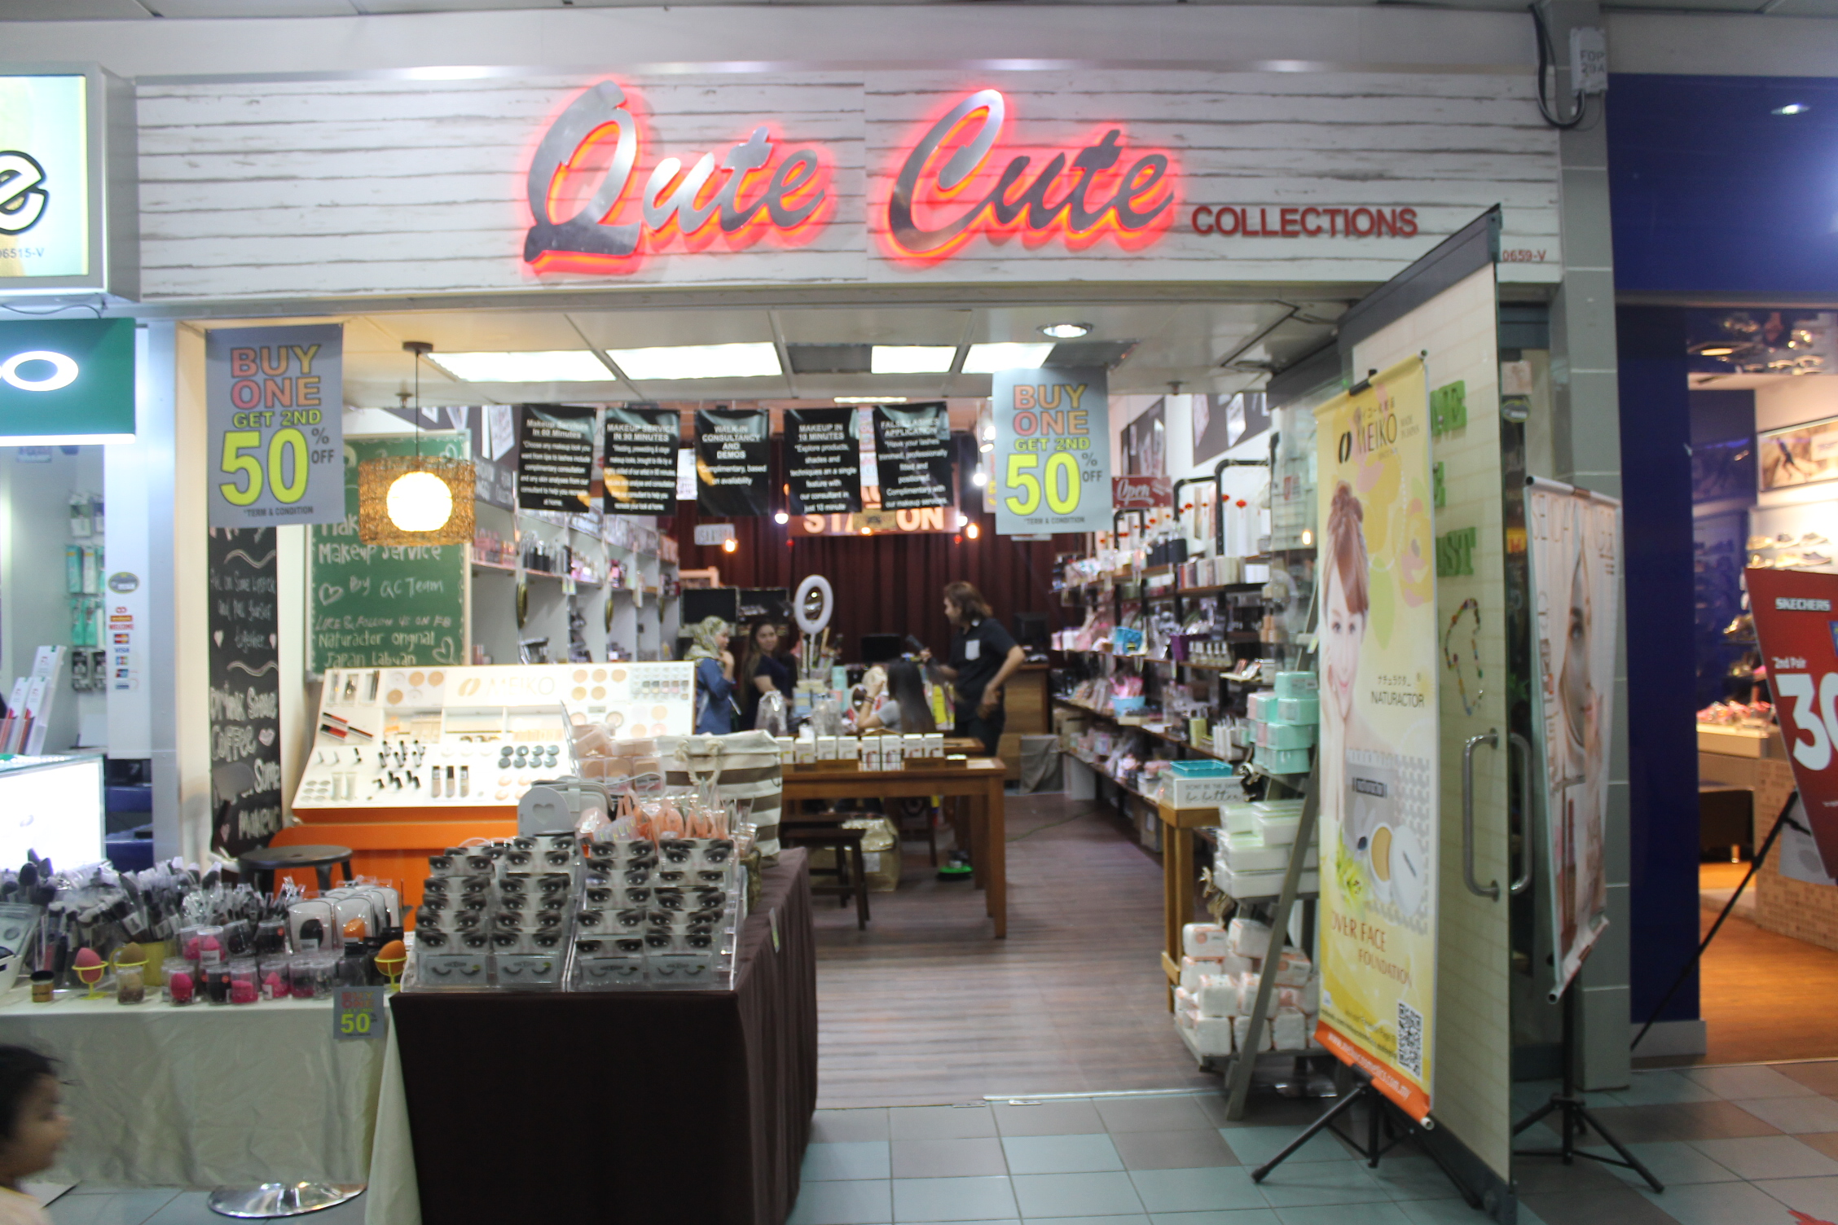

**-HEALTH AND BEAUTY**

* Mayfair Hair & Beauty unisex Saloon
* FT Hair Saloon
* Secret fragrance & cosmetic
* Qute Cute collection
* Cosway
* Guardian
* Fazerra beauty house
* GNC LiveWell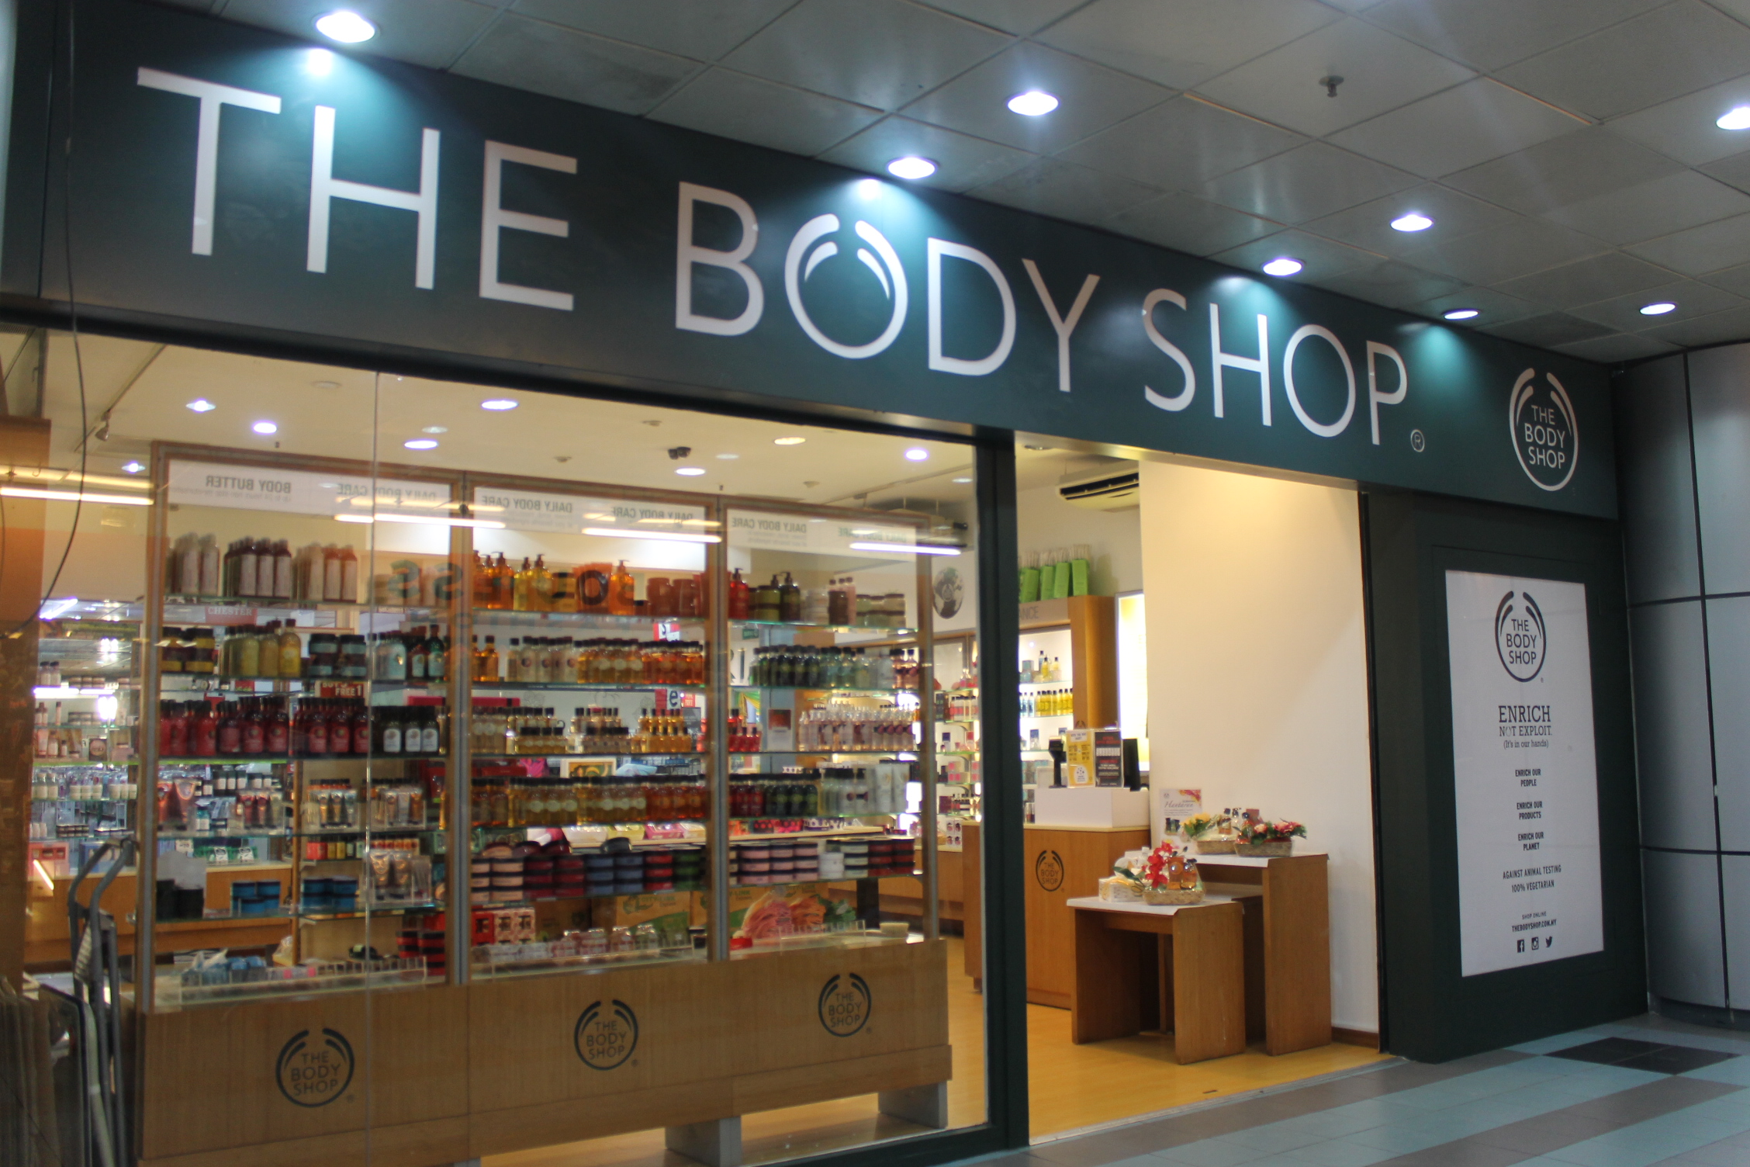
* Body Care Studio

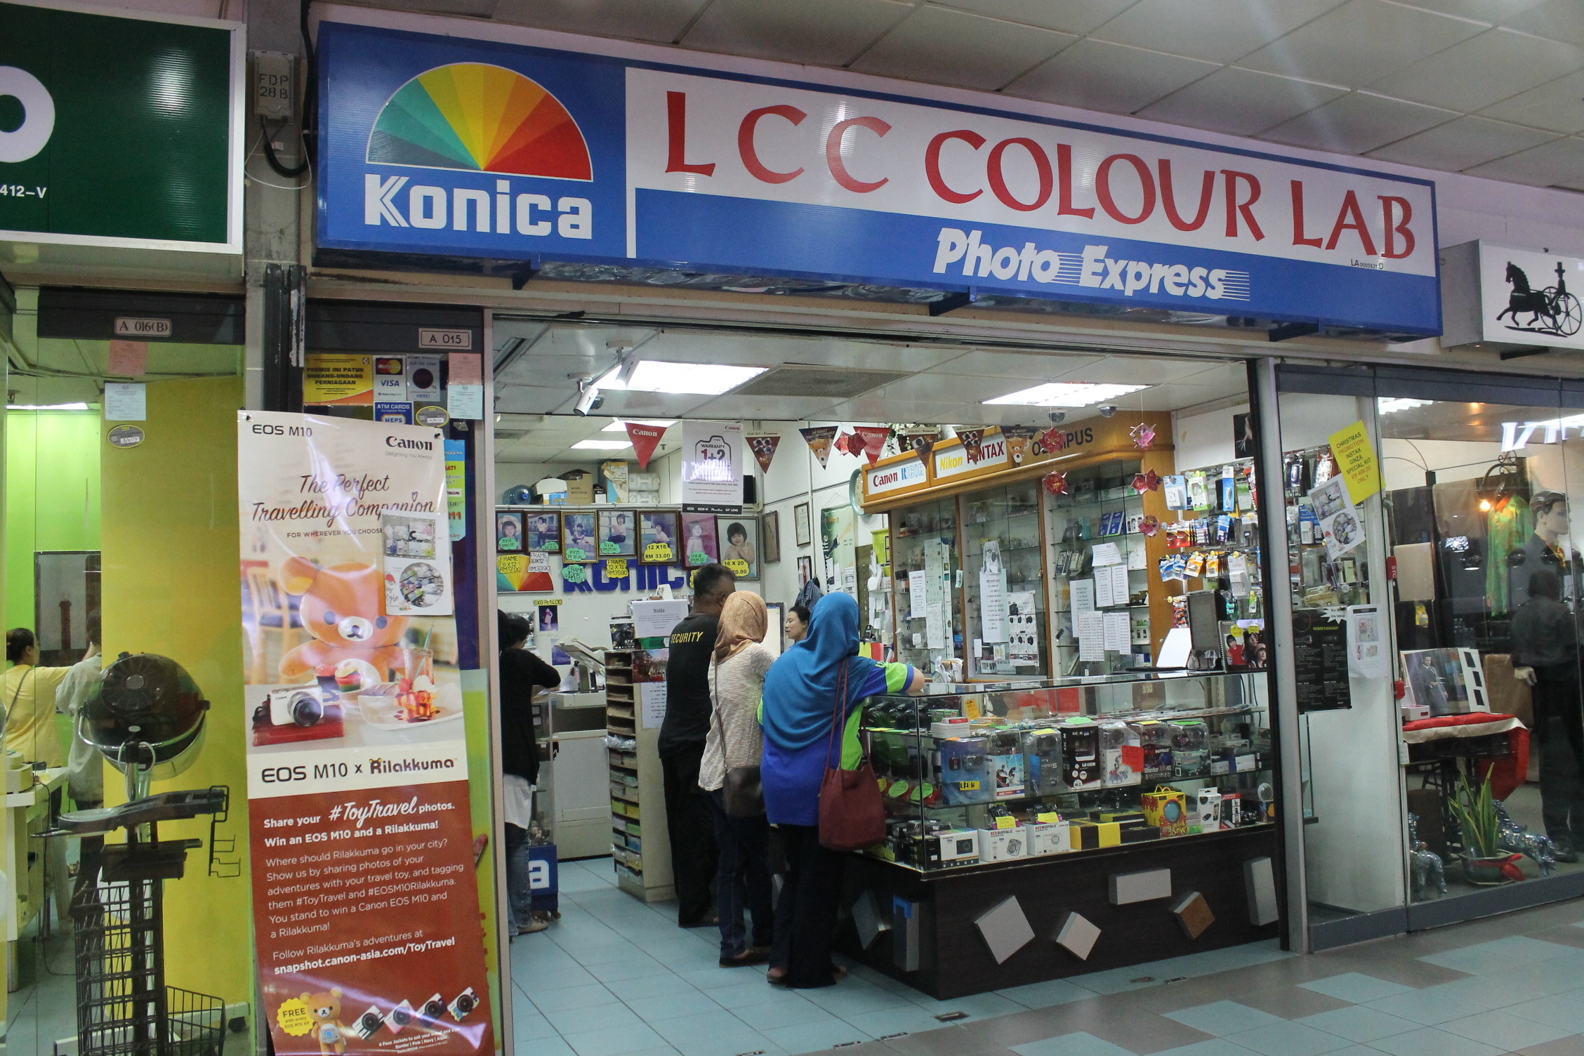

**-PHOTOGRAPHY**

* LCC Colour Cab

**-PHONE & COMPUTERS**

* Extreme computer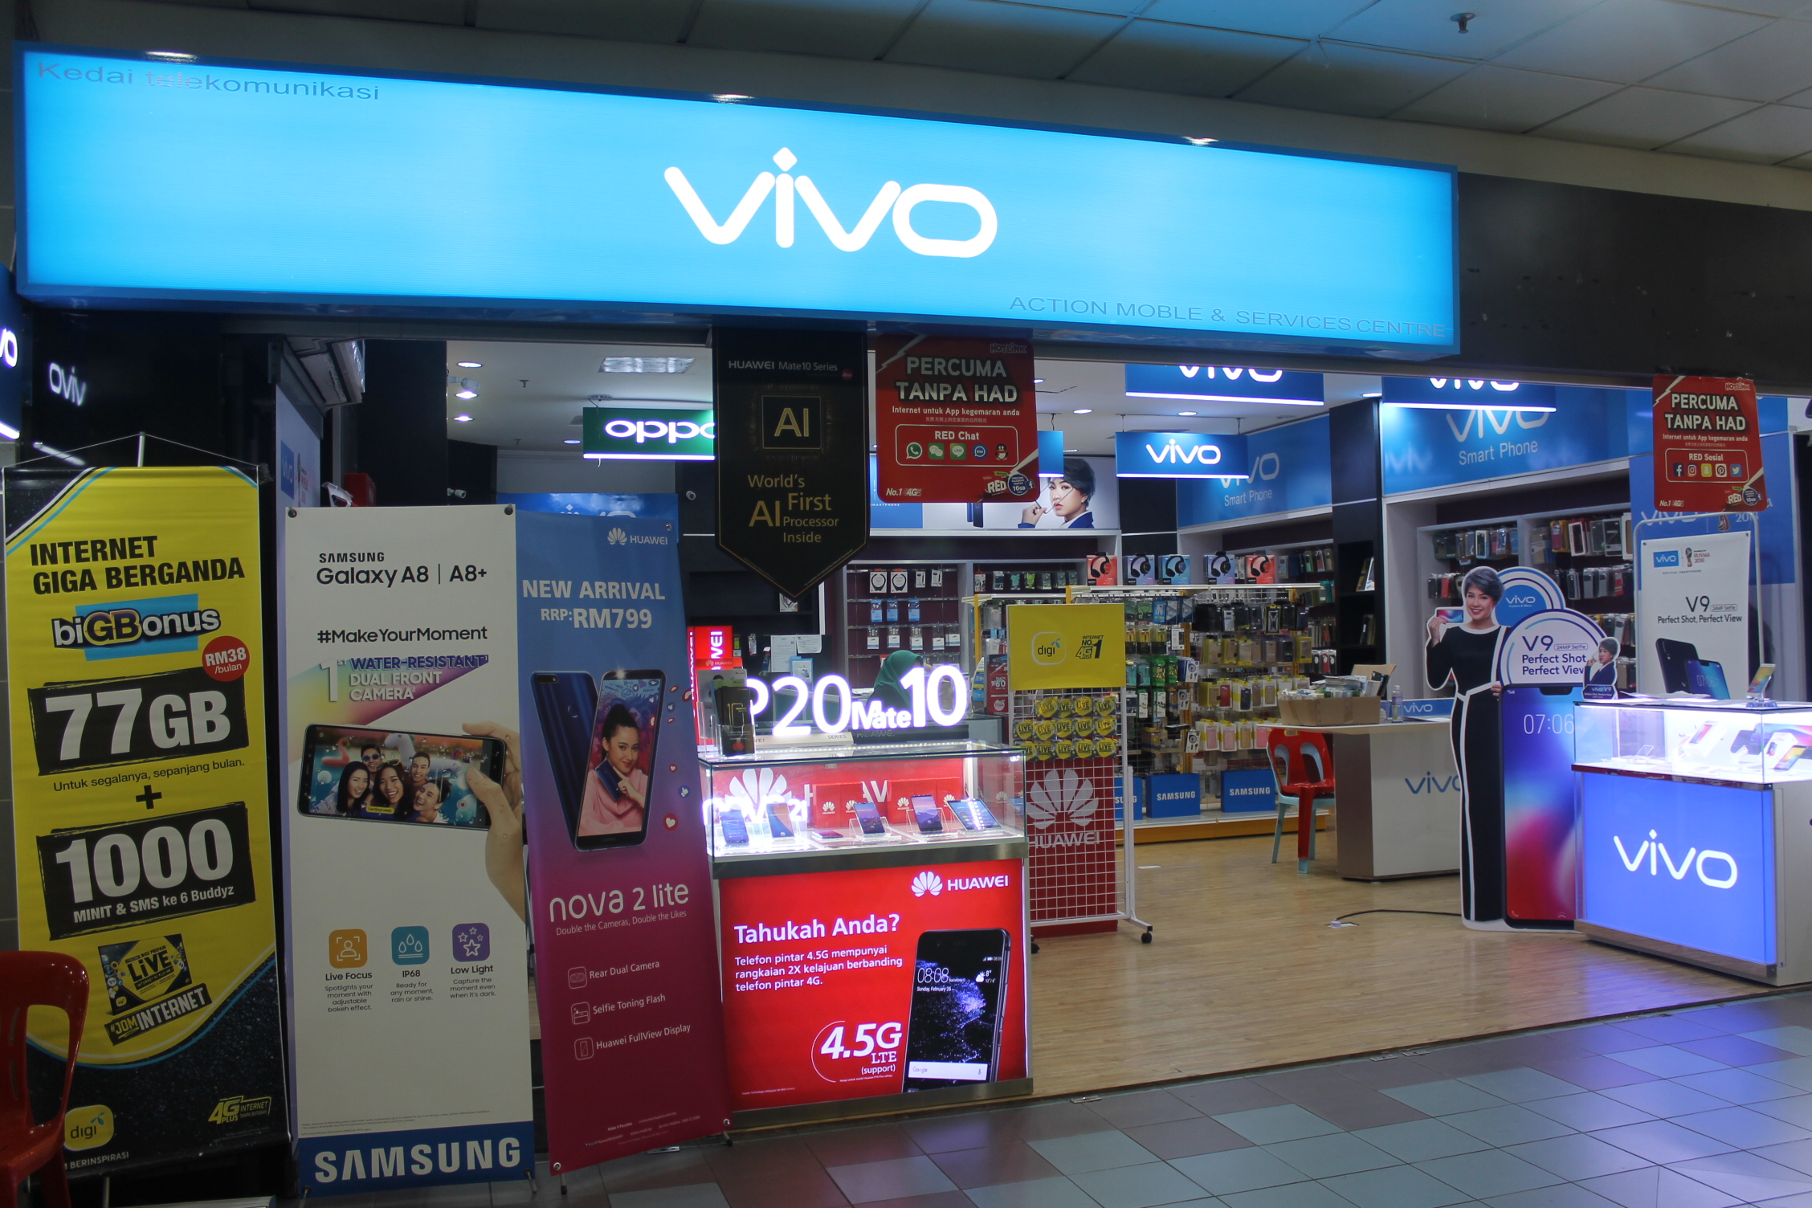
* OPPO
* VIVO
* DIGI
* Kedai Komputer Purnama IT
* NAJRAC enterprise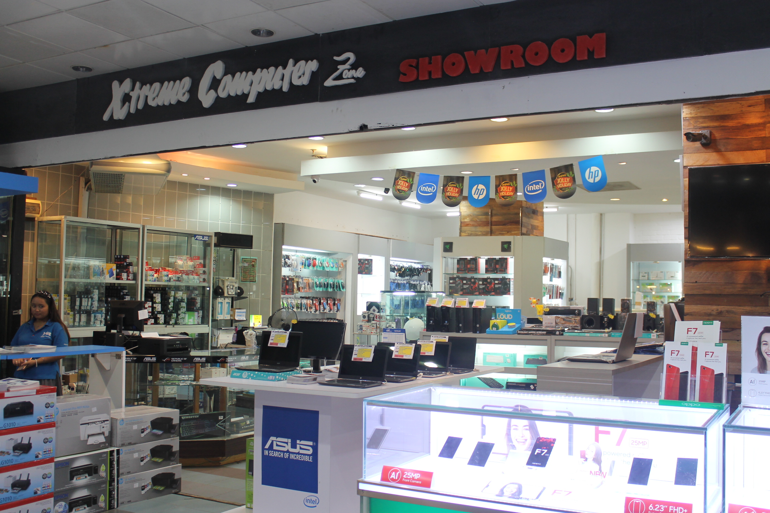

**-ACCESSORIES**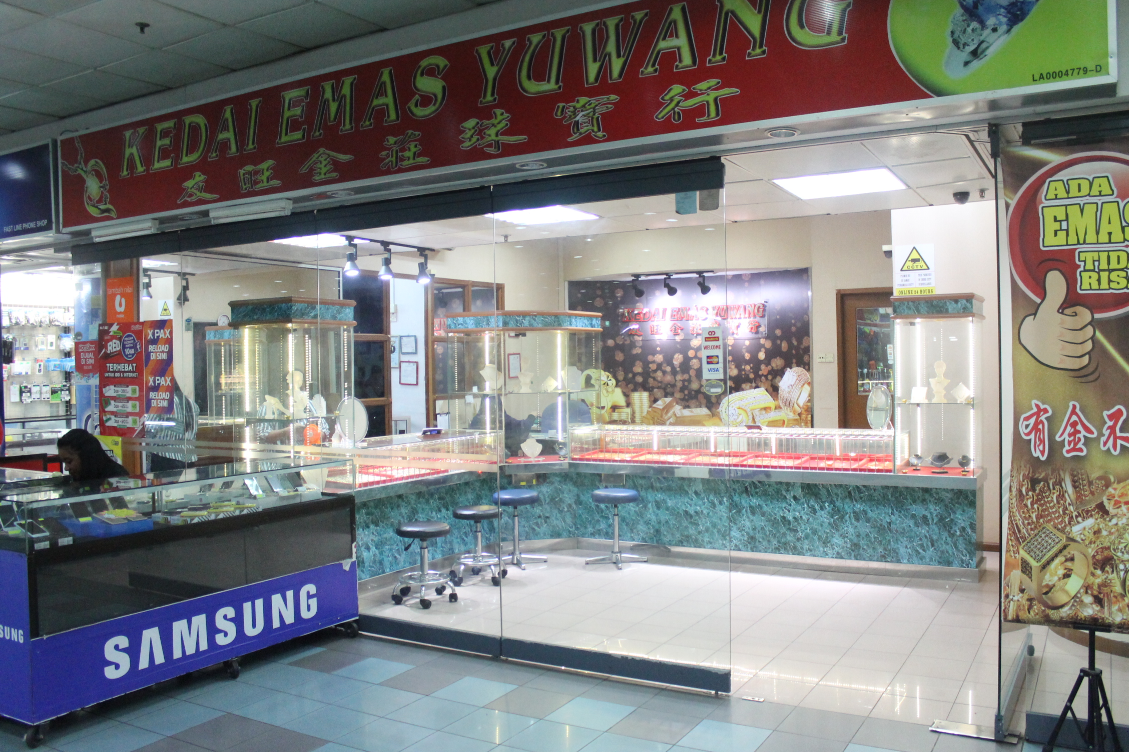

* AC Hidaya Jewels
* The Palace Concept
* Kedai Emas Yuwang

**-DUTY FREE**

* SKY PARK

**-TOYS**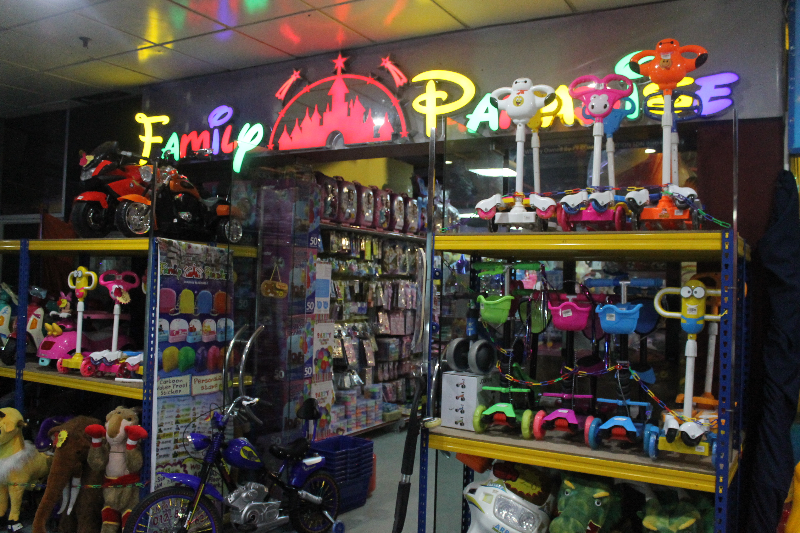

* Family Paradise

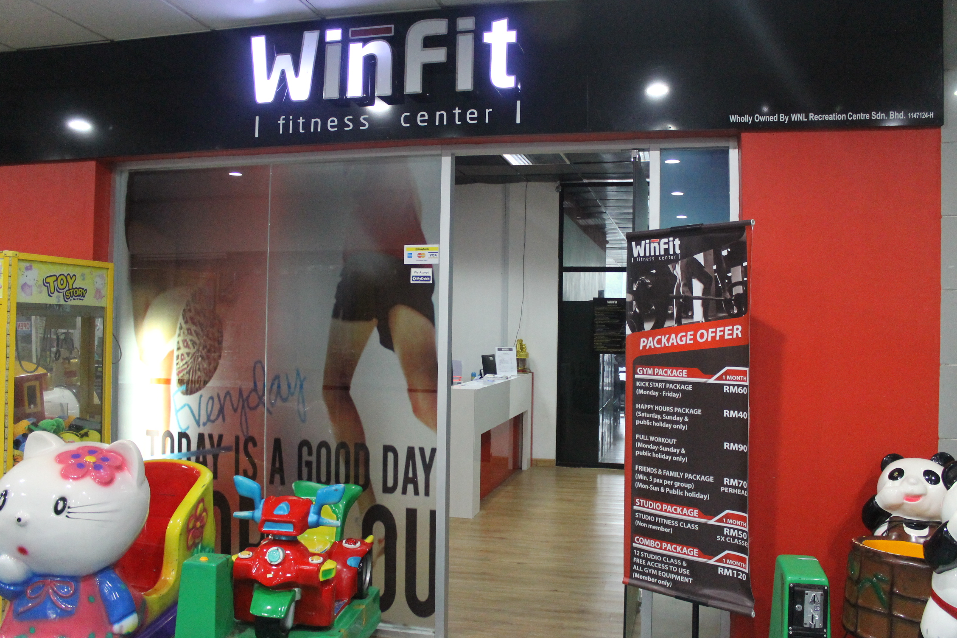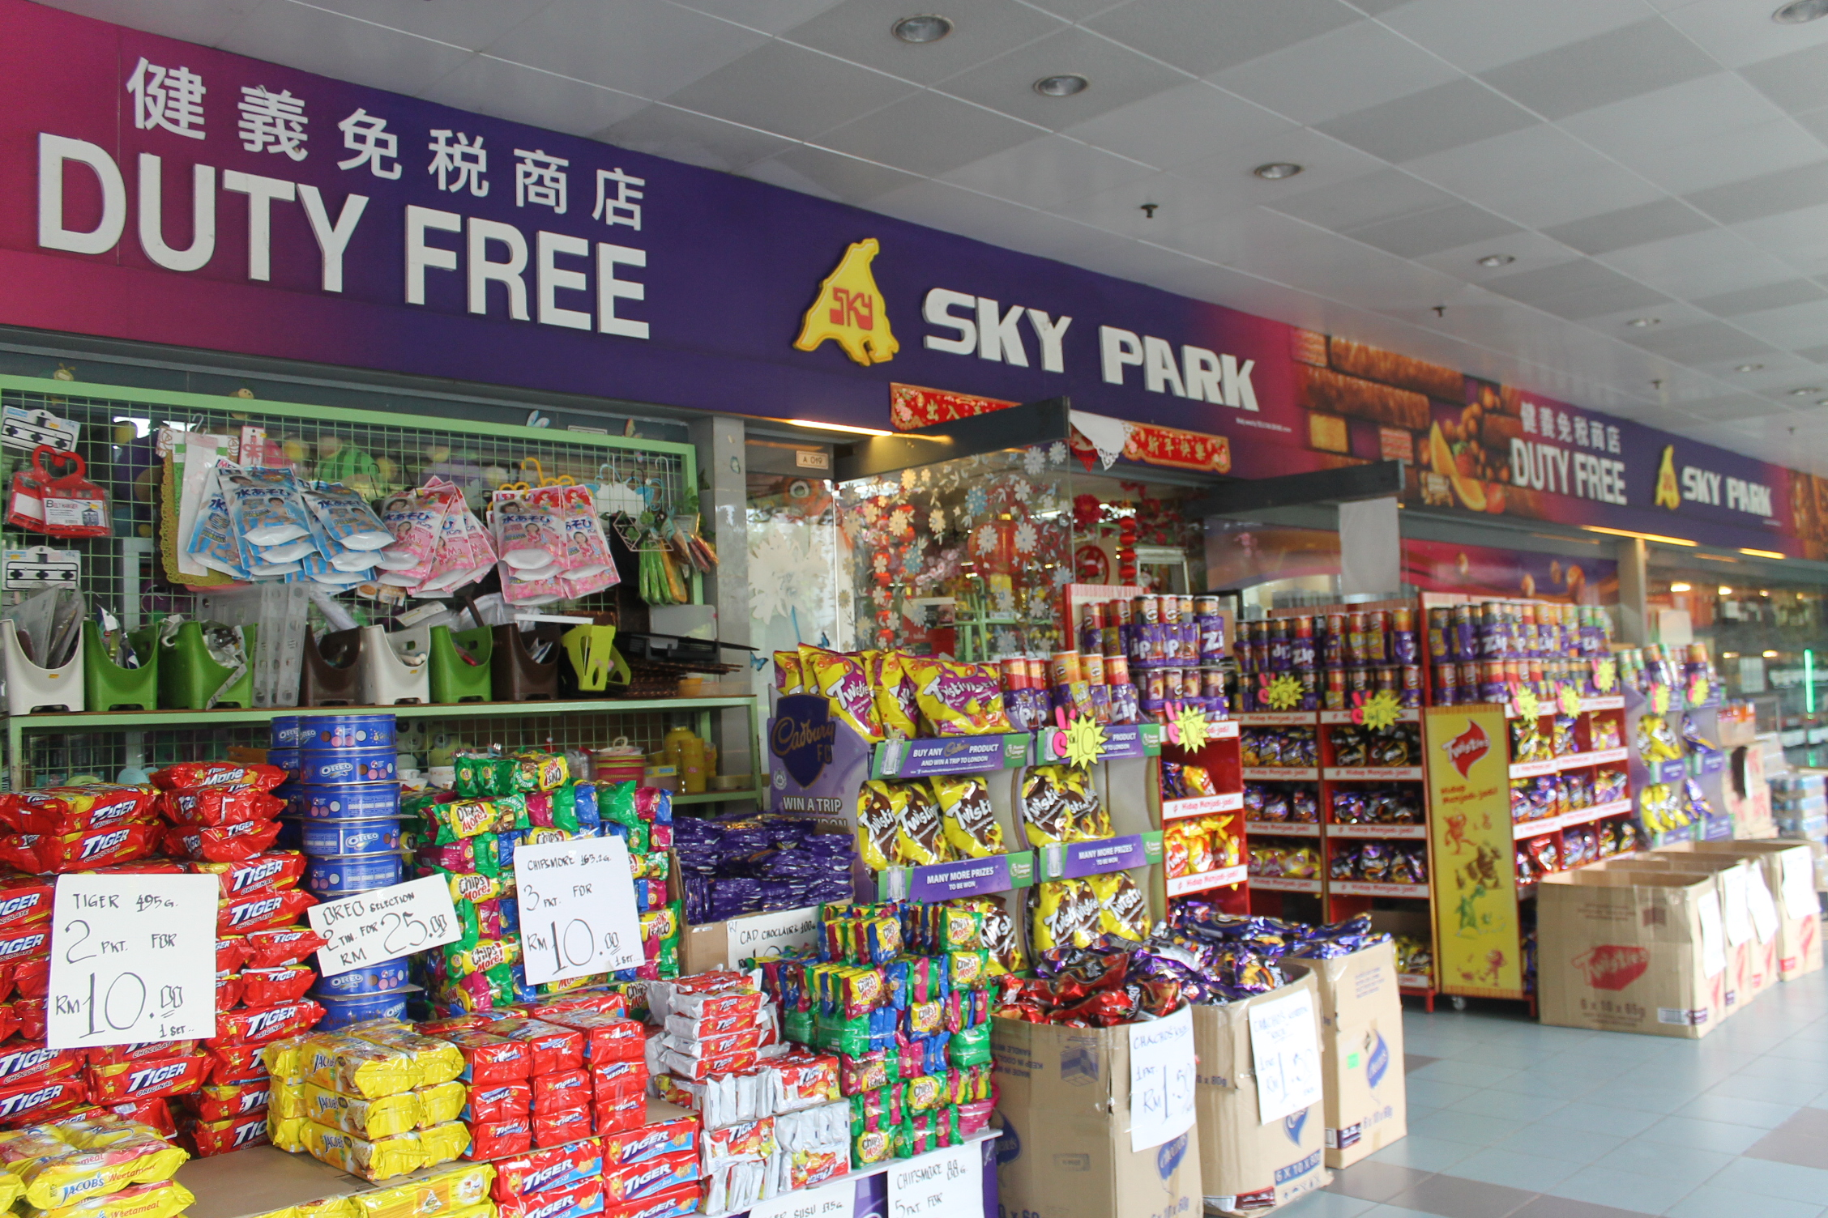

**-GYM**

* Win fit Fitness centre

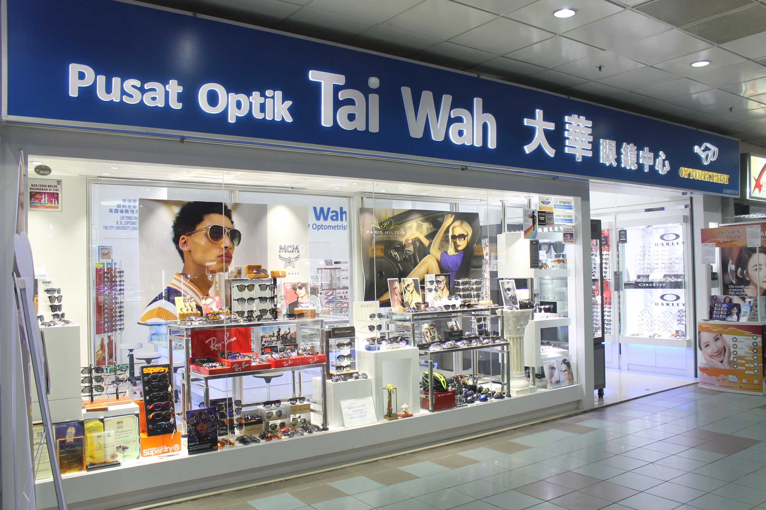

**-OPTICAL**

* **Pusat Optik Tai Wah**
* **Labuan Optic & Contact Lens centre**